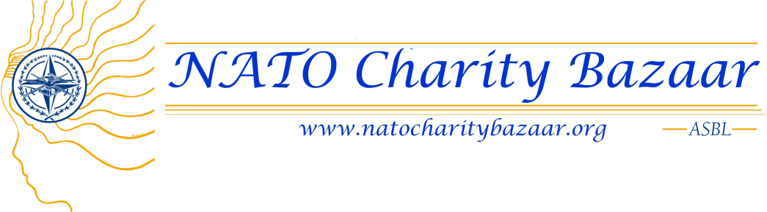
Invitation to the
NATO Charity Bazaar asbl
General Meeting
Tuesday, October 7, 2014

Dear National Representative and/or Assistant National Representative,

You are invited to attend the 7 October 2014 NATO Charity Bazaar General Meeting.

Date: Tuesday, October 7, 2014
Time: 10:00 hrs – 12:00 hrs
Location: NATO Staff Centre – Big Chalet

If you are Full Member and cannot attend the meeting, please send apologies to Jimmie Bradshaw (president@natocharitybazaar.org) ASAP and fill out the proxy voting form below. This form will give the person that you designate to attend the meeting the authority to vote on your behalf and to collect all distributed material.

Should you have any questions, please feel free to contact me.

I look forward to seeing you at the meeting on Tuesday, October 7, 2014.

Yours sincerely

Jimmie Bradshaw
President for NATO Charity Bazaar asbl
Tel: 0494-660-855 | president@natocharitybazaar.org

………………………………………………………………………................
PROXY FORM
Return to our Secretary, Sarah Kibble Bonifazi, at secretary@natocharitybazaar.org .

I, (full name)______________________________________________________
Full Member of the NATO Charity Bazaar asbl, give my proxy to
(full name)_________________________________________________________
to vote on my behalf at the General Meeting on Tuesday, October 7, 2014.

